Honor Orchestra
Audition material is page 52 in our textbook and does not need to be memorized. One to two students are selected per school for this prestigious group. Auditions will take place during class in January/February. If your child is selected, there are 5 evening rehearsals preceding a concert on Saturday, March 28, 2015. An audition application will be provided in January.

Benchmark Songs
During the 2nd Learning Cycle, your child will be learning a variety of songs that we will call “5th Grade Benchmark Songs.” When listening and watching your child, listen for a good sound (tone quality) and look for proper playing position and good posture. Your child should be able to play each of the songs along the following timeline:

November: Jingle Bells, Meeting Octave D’s, Cactus Gardens
December: Dreidl, Song of the Wind, Jolly Old St. Nicholas (A part)
January: D Major Scale and Arpeggio, We Will Rock You, Samba La Bamba

Music Grades
All students in grades 4 and 5 receive music grades during the 2nd and 3rd Learning Cycles. In previous years, music grades were given in the form of O (Outstanding), S (Satisfactory), AC (Area of Concern), and U (Unsatisfactory). As of the 2014-2015 school year, all music grades will be the same as the rest of the academic subjects: 4, 3, 2, 1. All students should be working toward the grade level standard(s) in music (Benchmark songs). By the end of December, your child should be able to play Dreidl, Song of the Wind, and Jolly Old St. Nicholas (A part & B part).

Testing
One of the best ways to gather information about a student’s playing ability is through testing in class. During the month of November, your child was tested on Jingle Bells (page 15, #44). During the month of December, your child will be tested on Dreidl (page 15, #45). Please see the rubric below for ways you can help your child prepare for this test.

Rubric for Dreidl

3 | 2 | 1
Your child is able to play Dreidl with good tone quality (good sound), posture, and position. Your child is able to play in tune (fingers on the stripes), with proper bow tracking (bow stays between the bridge and fingerboard), finger tunnels (keeping fingers on stripes whenever possible), and repeat signs (repeating the song when the music indicates to do so). | Your child is working toward being able to play Dreidl with good tone quality (good sound), posture, and position. Your child is working toward being able to play in tune (fingers on the stripes), with proper bow tracking (bow stays between the bridge and fingerboard), finger tunnels (keeping fingers on stripes whenever possible), and repeat signs (repeating the song when the music indicates to do so). | Your child is struggling to play Dreidl with good tone quality (good sound), posture, and position. Your child is struggling to play in tune (fingers on the stripes), with proper bow tracking (bow stays between the bridge and fingerboard), finger tunnels (keeping fingers on stripes whenever possible), and repeat signs (repeating the song when the music indicates to do so).
Instructions for Home Practice Guide Completion: Each week, your child’s practice should have a specific focus. We are providing you with practice goals and objectives for each week of the month. In most cases, your child will receive instruction on the material prior to playing the material at home. Each week, he/she needs to practice the assigned material repeatedly. Once your child feels prepared to play the assigned piece(s) for you, he/she will give you a short concert and/or explanation of the material. Once the concert is completed, please sign the appropriate week’s box.

Date | Page  #s | Pages Completed/Song(s) Played | Parent Signature
 | 15  18  binder | #45: Dreidl (Review, TEST NEXT WEEK)  #55: Song of the Wind (Review)  Jolly Old St. Nicholas (Review, A part & B part)
 | 20  binder | #62: Good King Wenceslas (Review, Play 2X)  Up on the Housetop (A part ONLY)
 | 17  20 | #53: Obsiwana  #60: Springtime Stomp
WINTER BREAK
Choose 2-3 songs to play for fun

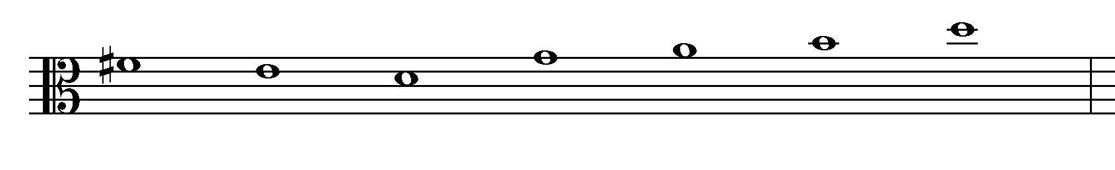
Write the correct note names below each note. Then write the fingerings below each letter name.
Letter Names:

Fingerings:

